**Experiment 1. Realization of Logic Gates and Familiarization of Verilog**

Date: 11/05/21

**AIM**

a.Write a verilog program for OR gate in gate level,data flow level and behavioral level modelling  
  
b.Write a verilog program for the boolean expression y=ab+bc+ac in gate level,data flow level and behavioral level modelling

**a. OR GATE**

**VERILOG CODE**

**Gate level**

module or_gate(output y,input a,b);

or(y,a,b);

endmodule

**Data flow level**

module or_gate

(input wire a,b,

output wire y);

assign y = a||b;

endmodule

**Behavioural level**

module or_gate(output reg y,input a,b);

always@(a or b)

begin

if(a==1'b0 & b==1'b0)

begin

y = 1'b0;

end

else

y = 1'b1;

end

endmodule

**Testbench**

`timescale 1ns/1ps

module test_or;

reg t_a,t_b;

wire t_y;

or_gate uut(.a(t_a),.b(t_b),.y(t_y));

initial

begin

$dumpvars(1,test_or);

t_a = 1'b0;

t_b = 1'b0;

#10;

t_a = 1'b0;

t_b = 1'b1;

#10;

t_a = 1'b1;

t_b = 1'b0;

#10;

t_a = 1'b1;

t_b = 1'b1;

#10;

$stop;

end

endmodule

**Output**

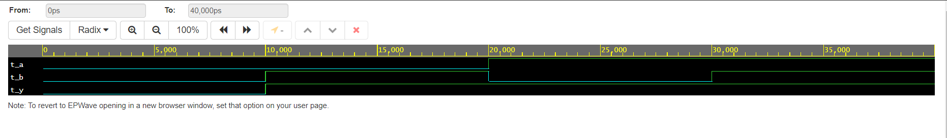

**b. y = ab+ac+bc**

**VERILOG CODE**

**Gate level**

module boolean_exp(output y,input a,b,c);

or(y,(a&b),(b&c),(a&c));

endmodule

**Data flow level**

module boolean_exp

(input wire a,b,c,

output wire y);

assign y = (a&b)|(b&c)|(a&c);

endmodule

**Behavioural level**

module boolean_exp(output reg y,input a,b,c);

always@(a or b or c)

begin

if((a==1'b1 & b==1'b1)||(a==1'b1 & c==1'b1)||(b==1'b1 & c==1'b1))

begin

y = 1'b1;

end

else

begin

y = 1'b0;

end

end

endmodule

**Testbench**

`timescale 1ns/1ps

module test_boolean_exp;

reg t_a,t_b,t_c;

wire t_y;

boolean_exp uut(.a(t_a),.b(t_b),.c(t_c),.y(t_y));

initial

begin

$dumpvars(1,test_boolean_exp);

t_a = 1'b0;

t_b = 1'b0;

t_c = 1'b0;

#10;

t_a = 1'b0;

t_b = 1'b0;

t_c = 1'b1;

#10;

t_a = 1'b0;

t_b = 1'b1;

t_c = 1'b0;

#10;

t_a = 1'b0;

t_b = 1'b1;

t_c = 1'b1;

#10;

t_a = 1'b1;

t_b = 1'b0;

t_c = 1'b0;

#10;

t_a = 1'b1;

t_b = 1'b0;

t_c = 1'b1;

#10;

t_a = 1'b1;

t_b = 1'b1;

t_c = 1'b0;

#10;

t_a = 1'b1;

t_b = 1'b1;

t_c = 1'b1;

#10;

$stop;

end

endmodule

**Output**

